Prot. N. 00184/18 Rome, February 2, 2018
World Day of Consecrated Life

To all the Brothers of the Order
Dear Brothers

May the Lord give you His peace!

Two years ago to the day, on the occasion of the World Day of Consecrated Life, we began the process of shared reflection on the Ratio Formationis by sending out a questionnaire to the entire Order. The results we collected at that time are still a source of guidance for us as we proceed with our work.

Among my responsibilities as General Minister of the Order these past twelve years, in my task of encouraging and accompanying my brothers, formation has been a fundamental priority. I have written four letters: Get up and walk, Let us fan the flame of our charism, Identity and belonging, and The indispensable gift of lay brothers. In them I wanted to share my experiences and my hopes for the future. And so, just as it was very satisfying to hand over the text of the new Constitutions to the General Chapter at the end of the last sexennium, I hope that during the next General Chapter the text of the Ratio Formationis will enable us to reflect together on the reality of our formation.

The Universal Church is preparing to celebrate the Synod of Bishops in Rome this coming October, on the theme of Young People, the Faith and Vocational Discernment, It is a happy coincidence that we, as an Order, are reflecting on formation. Let us make the most of this opportunity to listen to and learn from the whole Church, and also to put forward and share our experiences. The quality of the Order, indeed its very future, depends on how successfully we review the criteria, flowing from our charism, by which we discern vocations. It depends, too, on the thorough planning of formation programmes that take seriously the faith processes by which we become adult Christians.

The moment has now come to focus on the work of completing a comprehensive draft of chapter III of the Ratio, which aims to present the stages of formation in the light of the key concept of initiation. The text has to be set within the coordinates of time and space. On the one hand, the speed of social and cultural change leads us to think in terms of a flexible text, and on the other, the expansion of the Order and its cultural variety incline us towards a text that is richer in insights than in certainties.

It is the responsibility of the Major Superiors, not only of the formators, to continue to motivate and accompany their brothers, and to make sure that this process of reflection is participative and fraternal. What we are asking from you is this: check to see whether the five dimensions of formation which we studied in chapter II can be found in all the formation stages, as a true process of initiation. This is a task for all the brothers and for each fraternity, but in particular for the formators and all the brothers who are in initial formation.

One way of approaching the task could be: taking advantage of the Lenten season, after carefully reading a part of the text, why not hold a fraternity meeting to look at the reality of your formation as it actually is, according to the stage you find yourselves in? As chapter III says, we particularly appeal to those in the ongoing formation stage to take part. All contributions should be sent to the International Formation Councillor of your Conference by May 1st at the latest.
We have about 3 months to complete the task.

The General Formation Council will meet at our General Curia from 9th - 16th March. On this occasion, the purpose will be to draft, in the light of results received from the three continental meetings, the three Appendices that will accompany the Ratio: Affective and psycho-sexual maturity, a Directory of Studies, and the Cultural instrument by which the Ratio Formationis can be integrated into the formation plans of each circumscription. In addition, we have appointed a committee of specialists who will work between 1st and 5th June to edit the text and prepare a final version, which will be handed to the General Council. The Committee is composed of the following brothers:

- Br. Antonio Cristo (Africa), Consecrated Life
- Br. Néstor Bernardo Molina (America), Franciscanism
- Br. Albert D'Souza (Asia), Juridical Aspects
- Br. Roberto Tadiello (Europe), Biblical Theology
- Br. Fabio Chiodi, Graphic design
- Br. Víctor Herrero, Stylistic editor

I wish you all a happy and fruitful Lent. Walking together in the footsteps of the Lord Jesus, let us go up to Jerusalem, our eyes filled with the freedom and love inspired by Galilee. May Mary Immaculate, patron of our Order, continue to accompany us as we work to prepare the next General Chapter and the Ratio Formationis.

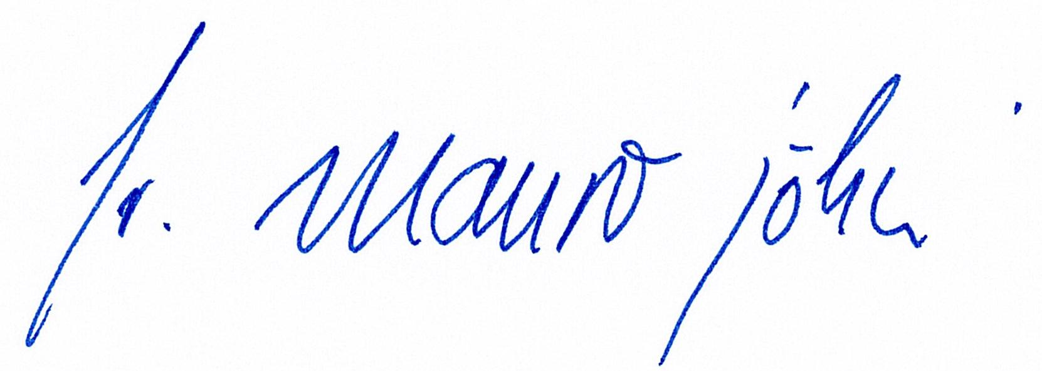
Fraternally,

Br. Mauro Jöhri
General Minister OFMCap.
Br. Charles Alphonse OFMCap.
General Secretary for Formation

