|  |  |
| --- | --- |
| Franciscan Family Conference | |
| Fr. Michael Anthony Perry  Ministro Generale OFM  Curia Generalizia  Via S. Maria Mediatrice, 25  00165 Roma  tel.: +39 - 0668.49.19  Fax: +39 - 0663.80.292  Fr. Marco Tasca  Ministro Generale OFMConv.  Curia Generalizia  Piazza Ss. Apostoli, 51  00187 Roma  tel.: +39 - 06699.571  fax: +39 - 06699.57321  Fr. Mauro Jöhri  Ministro Generale OFMCap.  Curia Generalizia  Via Piemonte, 70  00187 Roma  tel.: +39 - 064620.121  fax: +39 - 064620.1210  Fr. Nicholas Polichnowski  Ministro Generale TOR  Curia Generalizia  Via dei Fori Imperiali, 1  00186 Roma  tel.: +39 - 066920441  fax: +39 - 06678.4970  Tibor Kauser  Ministro Generale OFS  Béla Kiraly utja 98  2081 PILISCSABA  UNGHERIA  Sr. Deborah Lockwood  Ministra Generale O.S.F.  Via Cassia, 870  00189 Roma  tel.: +39-0633258201  fax: +39-0633252865  Presidente di turno CIF-TOR | To YouFra  World Youth Day 2016  Dear young Franciscans all over the world, may the Lord give you peace!  Our Seraphic Brother Saint Francis showed himself to be a true lover of God's mercy. Finding himself deeply loved by the "Father of Mercies" (Cf. 2 COR 1.3) while still in his youth, the poor man of Assisi allowed this virtue to embrace his life and become in him **availability**, **movement** and **liberation**. Francis himself manifested this dynamism when he writes in his Testament that the Lord led his heart so he could go among the lepers, giving and receiving mercy (Cf. Test 2-3).  In this direction, inspired by St. Francis, we want to make a triple invitation to young people around the world, and so we invite you to participate in this upcoming World Youth Day.  The first invitation is to **availability**. Is the ability to cultivate the docility of a heart that seeks to give direction one’s own life. Francis was an eternal seeker, an idealist who was trying to fulfill his dream, which at first was a desired going up the social ladder and then his dream became a deep desire to conform to Christ. Precisely because his heart was open to understanding the manifestations of God's love in his story, the young Francis managed to redefine the direction of his life, filling it with profound meaning.  Dear young people, never lose this **availability**. Remain always attentive to the many manifestations of mercy that the Lord gives to his daughters and sons. Listen with affection to the guidance of those who love you. Be brothers and sisters in solidarity with suffering people, particularly those who have been condemned to the invisibility of exclusion from a society that lives on the basis of profits: the poor, the sick, refugees, abandoned children, the elderly and many others. Always keep a healthy openness (availability) to dialogue and coexistence among the differences that characterize our time. Never abandon a life of prayer through which you can experience the action of God which touches and transforms the human heart. Never lose this **availability** inspired by the Lord!  The second call is to **movement**. We cannot remain in our structures, or get used to a comfortable life, because our Seraphic brother left us as a legacy a cloister which is as large as the world itself (Cf *Sacrum Commercium* 63). Typical of Franciscan life is the form of life proposal by Pope Francisco that we be an outgoing church, a field hospital, a Samaritan church that assists the injured and abandoned on the side of the road (Cf *Evangelii Gaudium*). Speaking directly to the youth of Argentina – with an invitation that is certainly valid for young people from all over the world –, during WYD 2013 in Rio de Janeiro in Brazil, the Pope urged: "What do I hope as a result of the world youth day? |
| I hope there's noise. I want you to be heard in your dioceses, I want the Church to go out into the streets, I want us to defend ourselves from all that is worldly, immobility, from what is convenience, clericalism, from everything that causes us to be closed in on ourselves. Parishes, schools, institutions are made to go out, if they don't they will become an NGO and the Church cannot be an NGO. May bishops and priests forgive me if some of you create confusion for them. Though this is my advice. Thank you for what you can do. " Be young people in **movement**.  The third is the invitation to **liberation**. Don't make the same mistake of the rich young person (Mk 10:17-27): he possessed riches, observed perfectly the laws and precepts, but even so he felt that something was missing. Jesus looked at him with love – which is how he looks at each of you – and invited him to leave everything and follow him. He became sad because he preferred not to heed the call of the Lord, for he was very rich. Attachment to riches prevented him from experiencing the grace of being very close to God.  Be inspired by Francis, who gave up all his wealth in exchange for the treasure of detachment, which turned him into a liberated man, free to love God, people and all creatures. He became brother to all in his complete **liberation**. Give yourselves liberally and without reservation to Christ and his project. Be bearers of mercy and offer it to all those you meet in this adventure that is the following of Christ. May this mercy completely dominate your mind – so that you can put all your intelligence and your talents into service of Justice – dominate your heart – so that you can pulsate with a love of God that is made manifest in every situation – dominate your feet – so you can walk without tiring to existential and geographical margins – dominate your hands – so you can outstretch to everyone who lives in need of help. The more generous is your **liberation**, the more you will be conformed, as the Lord says: "to those who have, more will be given" (Mt 13:12).  These are the three invitations I humbly present you. We hope with great joy to see you in Krakow where, together, with Christ and St. Francis, we may experience concretely that "blessed are the merciful for they shall receive mercy" (Mt 7:5). | |

Rome, 11th July 2016, Feast of St. Benedict, abbot.

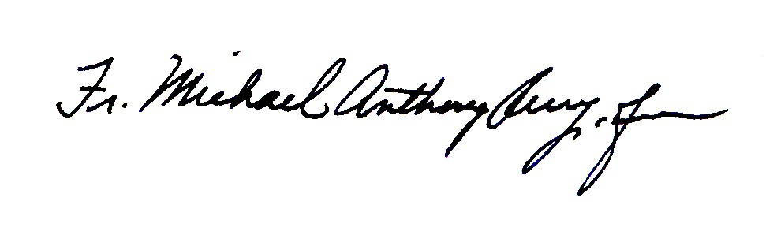

_________________________________ ___________________________

Fr. Michael Anthony Perry,OFM Sr. Deborah Lockwood, OSF

*Minister General Minister General*

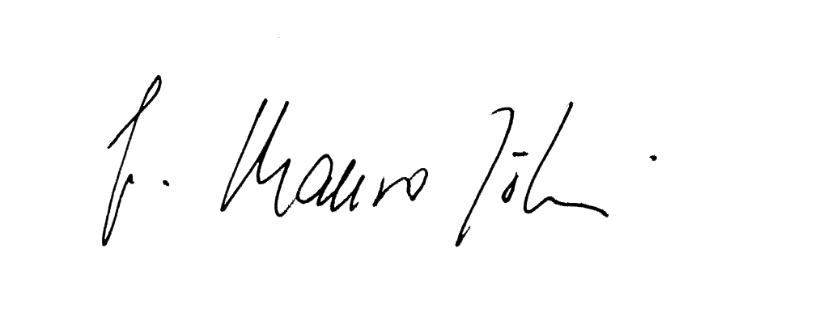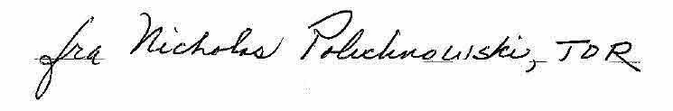

____________________________ ____________________________

Fr. Mauro Jöhri, OFMCap Fr. Nicholas Polichnowski, TOR

*Minister General Minister General*

*President FFC*

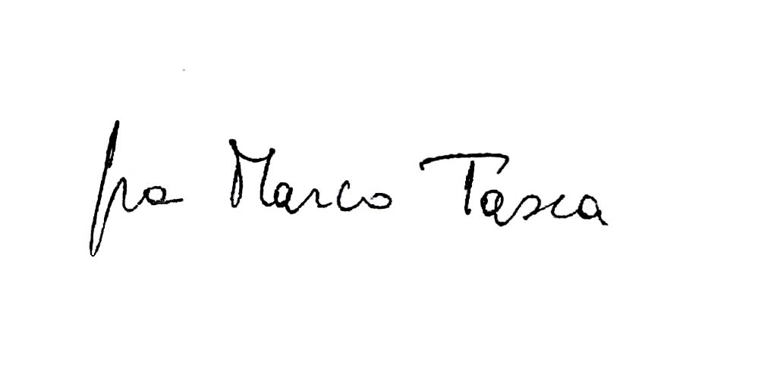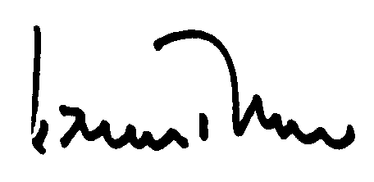

____________________________ ____________________________

Fr. Marco Tasca, OFMConv Tibor Kauser, OFS

*Minister General Minister General*